AWS PROJECT SESSIONS
Project Write-Up

01 | Project Overview

Project name | Project type
Mobile Phone App – Currency Converter | Mobile Phone App creation
Prepared by | Date
Stuart Allan | August 2026

One-line project summary
Create an mobile phone app to allow users to convert from one currency to another either with or without internet access

02 | Problem Statement

Who is this for?
People travelling to foreign countries (outside the area where you can use data roaming).

What problem exists today?
Current currency converter apps require internet access to work as they only use on-line currency exchange rates.
In areas where there is no internet connection, or countries where data roaming costs a small fortune, converting from one currency into another can be difficult or expensive.

What does success look like?
People will be able to convert from any currency into any other currency without the need for the internet.

03 | Proposed Solution

Solution overview
A mobile phone app will be coded and tested using AWS services before being hosted on the app stores.

Why cloud? Why AWS?
Cloud based is the correct solution as there will be minimal costs involved (possible zero under the free tier subscription).

Key features delivered
Download the app from the app stores.
Create an account personal to them.
Convert from one currency to another either by using an online conversion rate, or by using a user input conversion rate – off-line mode.
The ability to subscribe to other currencies that are not featured in the free version.

04 | Architecture Diagram

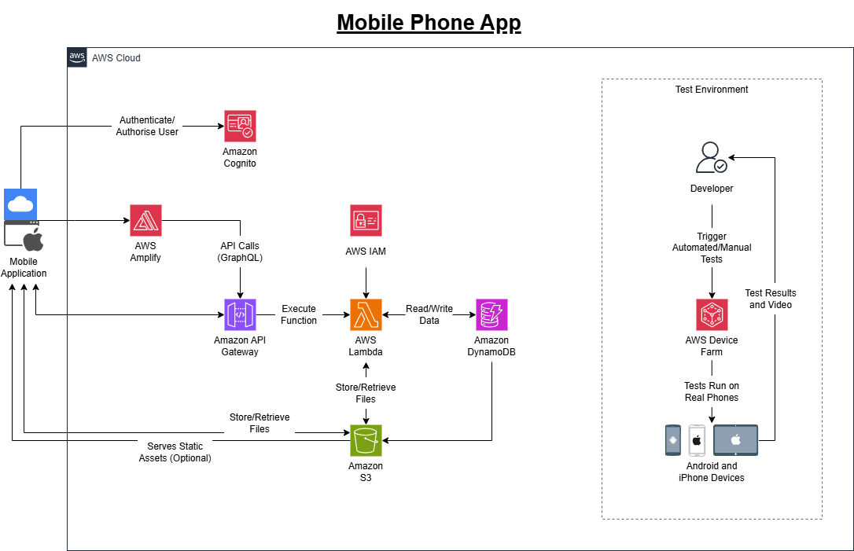

See additional notes at end

05 | AWS Services Used

Group services by category. For each service explain what it does in this specific project and why it was chosen over an alternative in the same category. The full services table is available as a separate Excel file for easy editing.
Service | What it does in this project | Why chosen over alternatives
COMPUTE
Lambda | [What it does in this project] | [Why chosen over a similar alternative]
STORAGE
S3 | [What it does in this project] | [Why chosen over a similar alternative]
NETWORKING & DELIVERY
API Gateway | [What it does in this project] | [Why chosen over a similar alternative]
DATABASE
DynamoDB | [What it does in this project] | [Why chosen over a similar alternative]
SECURITY & IAM
Cognito | [What it does in this project] | [Why chosen over a similar alternative]
FRONT-END WEB AND MOBILE SERVICES
Amplify | [What it does in this project] | [Why chosen over a similar alternative]
Device Farm | [What it does in this project] | [Why chosen over a similar alternative]

06 | Application Flow

Describe how data moves through the system step by step. Trace each flow from the user action to the final response. Use plain language.
Flow 1 — [Name your first flow, e.g. Visitor loads the website]
- Step 1: [e.g. Visitor types the domain name into their browser]
- Step 2: [e.g. Route 53 translates the domain to the CloudFront distribution]
- Step 3: [e.g. CloudFront checks its cache — serves from edge if cached]
- Step 4: [e.g. If not cached, CloudFront fetches from S3 via Origin Access Control]
- Step 5: [e.g. Browser loads the page and calls the visitor counter API]
- Step 6: [Continue tracing the flow...]

Flow 2 — [Name your second flow, e.g. Visitor submits contact form]
- Step 1: [e.g. Visitor fills in the form and clicks Send]
- Step 2: [e.g. Browser sends a POST request to the API Gateway endpoint]
- Step 3: [e.g. API Gateway triggers the contact-form Lambda function]
- Step 4: [e.g. Lambda reads the form data and validates it]
- Step 5: [e.g. Lambda calls SES to send an email to the site owner]
- Step 6: [e.g. Lambda returns a success response — browser shows confirmation]

07 | Security

A client will always ask how their data is protected. Describe every security control implemented in this project.
Security control | How it is implemented in this project | Status
HTTPS / TLS encryption | [Describe how HTTPS is enforced — e.g. CloudFront redirects HTTP to HTTPS. All traffic encrypted in transit via TLS.] | [ ] Implemented
Private S3 bucket | [e.g. Block All Public Access enabled. Only CloudFront can access the bucket via Origin Access Control (OAC).] | [ ] Implemented
IAM least privilege | [e.g. Lambda execution role grants only DynamoDB read/write and SES send — no other permissions.] | [ ] Implemented
No hardcoded credentials | [e.g. No AWS keys in code. Lambda uses IAM execution role. Table names in environment variables.] | [ ] Implemented
CORS configured | [e.g. API Gateway CORS allows requests only from the application domain, not all origins.] | [ ] Implemented
SSL Certificate | [e.g. Free ACM certificate issued in us-east-1, auto-renewing, attached to CloudFront distribution.] | [ ] Implemented
[Add further controls] | [Describe the control] | [ ] Implemented

Known limitations / not implemented in this version
[Being honest about limitations is professional. e.g. Rate limiting on the contact form API is not implemented in this version. A production deployment would add AWS WAF rules to prevent spam.]

08 | Cost Estimate

Every client will ask what this costs. Provide a monthly estimate. Use the AWS Pricing Calculator at calculator.aws to verify figures. Round to 2 decimal places.
Service | Usage assumption | Free Tier cost/month | Production cost/month
[AWS Service] | [e.g. 10,000 page views/month] | [e.g. £0.00] | [e.g. £0.50]
[AWS Service] | [usage] | [£0.00] | [£X.XX]
[AWS Service] | [usage] | [£0.00] | [£X.XX]
[AWS Service] | [usage] | [£0.00] | [£X.XX]
[AWS Service] | [usage] | [£0.00] | [£X.XX]
[Domain (optional)] | [.co.uk domain + Route 53 hosted zone] | [N/A] | [~£1.15/month]
ESTIMATED MONTHLY TOTAL |  | [£0.00] | [£X.XX/month]

09 | Next Steps & Future Improvements

Planned improvements for the next version
[List what you would add with more time or budget. Example: • Add AWS WAF to protect the API from spam and abuse • Add CloudWatch dashboards for real-time monitoring • Implement CI/CD via GitHub Actions for automatic deployment • Add a blog section backed by DynamoDB]

GitHub repository link | Live project URL
[https://github.com/username/aws-projects] | [https://yourdomain.co.uk]

Authenticate/Authorise User:
Mobile Application Amazon Cognito:
When a user opens the app or logs in, the mobile client communicates directly with Amazon Cognito using standard protocols (OAuth2/OIDC). Cognito verifies user credentials, and returns JSON Web Tokens (JWTs) to the mobile app to authorise subsequent API requests

API Calls (GraphQL):
Mobile Application/AWS Amplify Amazon API Gateway:
The mobile app makes HTTPS API requests (using AWS Amplify SDKs to simplify requests) to Amazon API Gateway. API Gateway acts as the single entry point, managing throttling, security, and validating the JWT tokens received by Cognito before allowing access to backend logic.

Execute Function:
Amazon API Gateway AWS Lambda:
Upon receiving a valid request, API Gateway triggers an AWS Lambda function. Lambda runs serverless code on demand (handling business logic such as processing an order, calculating data, or updating user profiles) without requiring persistent virtual servers.

Read/Write Data:
AWS Lambda Amazon DynamoDB:
The Lambda function interacts with Amazon DynamoDB to retrieve or update structured NoSQL application data (such as user accounts, messages, app settings, or transaction histories) with low latency.

Store/Retrieve Files:
Lambda/Mobile App Amazon S3:
For unstructured binary assets (e.g. user profile pictures, videos, PDF documents, or media files), data is written to or fetched directly from Amazon S3. Lambda often generates secure pre-signed URLs so the mobile app can upload or download files directly to/from S3 safety.

Serves Static Assets (Optional):
Amazon S3/Amplify Mobile Application:
Serves static content, configuration files, or web-based hybrid assets stored in Amazon S3 directly to the mobile app for rendering.

Trigger Automated/Manual Tests:
Developer AWS Device Farm:
During the app development and continuous integration phase, developers upload build binaries (.apk or .ipa files) and test scripts (written in Appium, XCTest, or Espresso) to AWS Device Farm.

Tests Run on Real Phones:
AWS Device Farm Physical Test Devices (iPhone, Android):
AWS Device Farm provisions requested physical iOS and Android devices in the cloud and executes the uploaded test scripts on real hardware to detect hardware-specific crashes, UI issues, or performance slowdowns.

Test Results and Video:
Physical Test Devices Developer:
Once testing completes, Device Farm aggregates diagnostic data – including video recordings of the test execution, device logs, performance metrics (CPU, RAM), and crash reports – and provides them back to the developer for debugging.

